**CRICKET SCORECARD MANAGEMENT**

**A Mini Project**

**Academic Year: 2021 – 22(ODD SEMESTER)**

**Department with Specialization :B.Tech. – Computer Science and   
 Engineering spl. in AI-ML  
Semester : I**  
**Course Code : 18CSS101J**  
**Course Title : Programming for Problem  
 Solving**

*Submitted by*

Sneha Patnaik (RA2111026010256)

Shreeya Chauhan (RA2111026010276)

*Under the Guidance of*

Dr. A. Suresh

(Associate Professor, NWC)



DEPARTMENT OF COMPUTING

COLLEGE OF ENGINEERING AND TECHNOLOGY

SRM INSTITUTE OF SCIENCE ANDTECHNOLOGY  
KATTANKULATHUR- 603 203

JANUARY2022

Aim

To manage the scoresheet and details of a cricket match

Abstract

This Project is designed to maintain the cricket scorecard i.e., Match summary. Batsman and bowler Information.

This File Consist:

1. Input the details of batsman: - Name, no of balls played, one, two, three, four six runs,

strike rate

2. Input the details of bowler: name, overs, no of balls, wickets, economy

3. Display match summary, batsman details, bowlers’ details according to user’s choice

**ALGORTIHM**

STEP 1 : Start

STEP 2 : Form a user defined function for batsman

STEP 3 : Declare character variable - name

STEP 4 : Declare integer variables - runs, score, balls, toruns, tobal, ones, twos, threes, fours, sixes, max_six, max_run, max_four

|  |
| --- |
|  |

STEP 5 : Declare float variable – str

STEP 6 : Declare array – pl1[100],pl3

STEP 7 : Form a user defined function for bowler

STEP 8 : Declare character variable - name

STEP 9 : Declare integer variables -runsgv, wkttkn, overs, max_w

STEP 10 : Declare float variable – econ

STEP 11 : Declare array – pl2[100],pl4

STEP 12 : Declare integer variables - plno, choice, i, n, m

STEP 13 : Print the statements asking for the details of the batsman and his number

STEP 14 : Store the information that has been input in variable m

STEP 15 : Take inputs of details of batsman

STEP 16 : Store the inputs entered

STEP 17 : Take inputs of details of bowler

STEP 18 : Store the inputs entered

STEP 19 : Print a choice panel and take input – 1)Batsman details 2)Bowler details 3)Match summary 4)Exit

STEP 20 : Store the choice number input

STEP 21 : Under choice 1, print ‘Enter batsman number to see details’ and take input

STEP 22 : Store the input

STEP 23 : Print batsman details according to the number entered

STEP 24 : Under choice 2, print ‘Enter bowler number to see details’ and take input

STEP 25 : Store the input

STEP 26 : Print bowler details according to number entered

STEP 27 : Under choice 3, print match summary

STEP 28 : Under choice 4, exit

STEP 29 : If any other choice number is entered except the given, print ‘Enter the correct choice’

STEP 30 : End

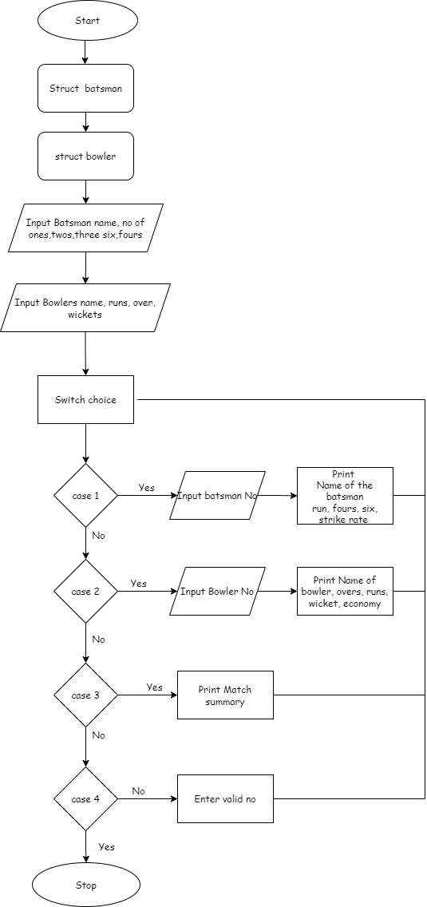

**SOURCE CODE**

#include<stdio.h>

#include<stdlib.h>

struct batsman

{

char name[25];

int runs,score,balls,toruns,tobal,ones,twos,threes,fours,sixes;

float str;

}pl1[100],pl3;

struct bowler

{

char name[25];

int runsgv,wkttkn,overs;

float econ;

}pl2[100],pl4;

int main()

{

int plno,choice;

int i,n,m;

printf("Enter the number of batsman \n");

scanf("%d",&m);

for(i=0;i<m;i++)

{

printf("Enter name of batsman%d:\n",i+1);

scanf("%s",pl1[i].name);

printf("Enter the number of ones scored by player%d:\n ",i+1);

scanf("%d",&pl1[i].ones);

printf("Enter the number of twos scored by player%d:\n ",i+1);

scanf("%d",&pl1[i].twos);

printf("Enter the number of threes scored by player%d:\n ",i+1);

scanf("%d",&pl1[i].threes);

printf("Enter the number of fours scored by player%d:\n ",i+1);

scanf("%d",&pl1[i].fours);

printf("Enter the number of sixes scored by player%d:\n ",i+1);

scanf("%d",&pl1[i].sixes);

printf("Enter the balls played by the player%d:\n",i+1);

scanf("%d",&pl1[i].balls);

}

printf("Enter the number of bowlers:\n");

scanf("%d",&n);

for(i=0;i<n;i++)

{

printf("\nEnter name of bowler%d:",i+1);

scanf("%s",pl2[i].name);

printf("Enter the runs given by the bowler%d:\n ",i+1);

scanf("%d",&pl2[i].runsgv);

printf("Enter the overs bowled by the bowler%d:\n",i+1);

scanf("%d",&pl2[i].overs);

printf("Enter the wickets taken by the bowler%d\n",i+1);

scanf("%d",&pl2[i].wkttkn);

}

do

{

printf("Enter the choice:\n 1)Batsman detail\n 2)Bowlers detail\n 3)Match summary\n 4)Exit\n ");

scanf("%d",&choice);

switch(choice)

{

case 1:

printf("Enter the batsman number\n");

scanf("%d",&plno);

plno--;

printf(" Player Detail\n");

printf("===========================================================================\n");  
printf(" Batsman runs balls fours sixes sr \n"); printf("===========================================================================\n");  
 pl1[plno].runs=(1*pl1[plno].ones)+(2*pl1[plno].twos)+(3*pl1[plno].threes)+(4*pl1[plno].fours)+(6*pl1[plno].sixes);

pl1[plno].str=(pl1[plno].runs*100.00)/pl1[plno].balls;

printf(" %-15s %-14d %-13d %-11d %-11d %-9.2f\n\n",pl1[plno].name,pl1[plno].runs,pl1[plno].balls,pl1[plno].fours,pl1[plno].sixes,pl1[plno].str);

break;

case 2:

printf("Enter the bowlers number\n");

scanf("%d",&plno);

plno--;

printf(" Player Detail\n ");

printf("=================================================================\n");

printf(" Bowler overs runs wicket economy\n");

printf("=================================================================\n");

for(i=0;i<n;i++)

{   
 pl2[plno].econ=pl2[plno].runsgv/pl2[plno].overs;

printf(" %-15s %-14d %-13d %-11d %-11.2f\n \n", pl2[plno].name ,pl2[plno].overs, pl2[plno].runsgv,pl2[plno].wkttkn,pl2[plno].econ); }

break;

case 3:

printf(" Match summary\n");

printf("==========================================================================\n");  
printf(" Batsman runs balls fours sixes sr \n"); printf("==========================================================================\n");

for(i=0;i<1;i++){   
   
pl1[i].runs=(1*pl1[i].ones)+(2*pl1[i].twos)+(3*pl1[i].threes)+(4*pl1[i].fours)+(6*pl1[i].sixes);

pl3.toruns+=pl1[i].runs;

pl1[i].str=(pl1[i].runs*100.00)/pl1[i].balls;

printf(" %-15s %-14d %-13d %-11d %-11d %-9.2f\n\n", pl1[i].name, pl1[i].runs,

pl1[i].balls,pl1[i].fours,pl1[i].sixes,pl1[i].str);

}

printf("TOTAL RUNS:%d\n\n",pl3.toruns);

printf("\n\n");

printf("=================================================================\n");

printf(" Bowler overs runs wicket economy\n");

printf("=================================================================\n");

for(i=0;i<n;i++)

{pl2[i].econ=pl2[i].runsgv/pl2[i].overs;

printf("%-15s %-14d %-13d %-11d %-11.2f\n\n\n", pl2[i].name, pl2[i].overs,

pl2[i].runsgv,pl2[i].wkttkn,pl2[i].econ);

}

break;

case 4:

exit(1);

default:

printf("Enter the correct choice\n");

break;}

}while(choice!=4);

return 0;}

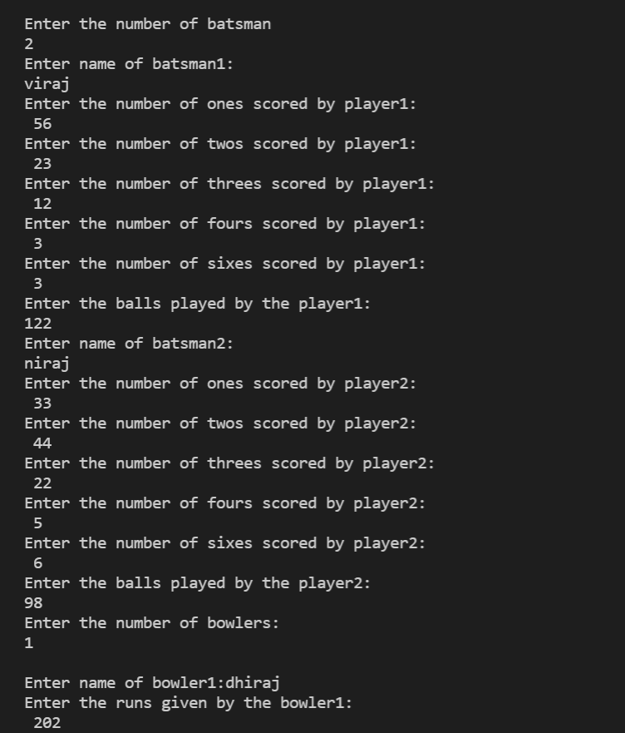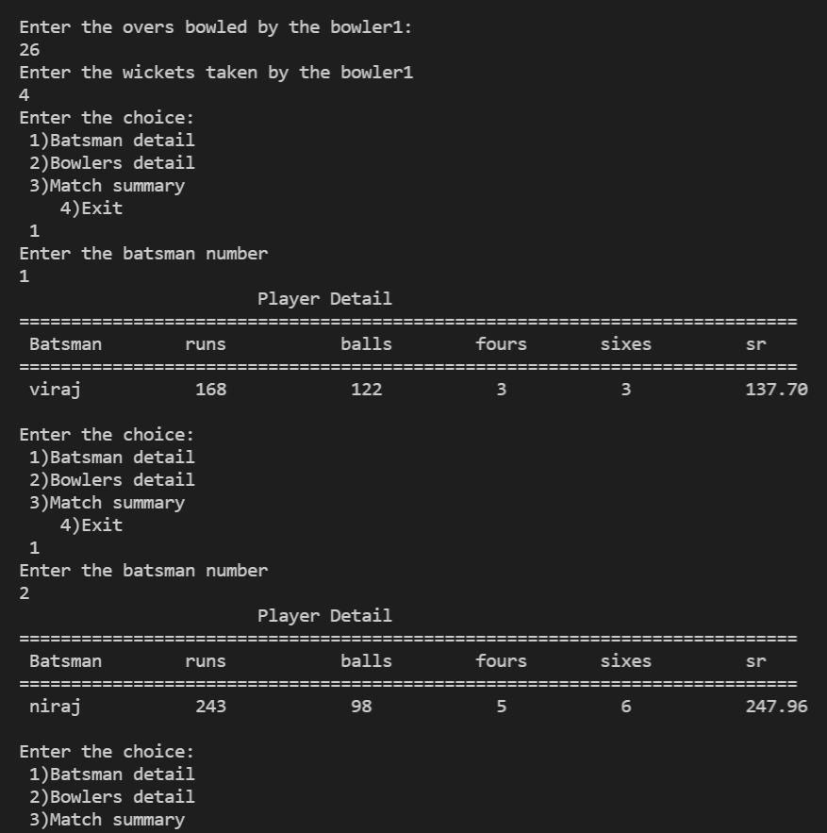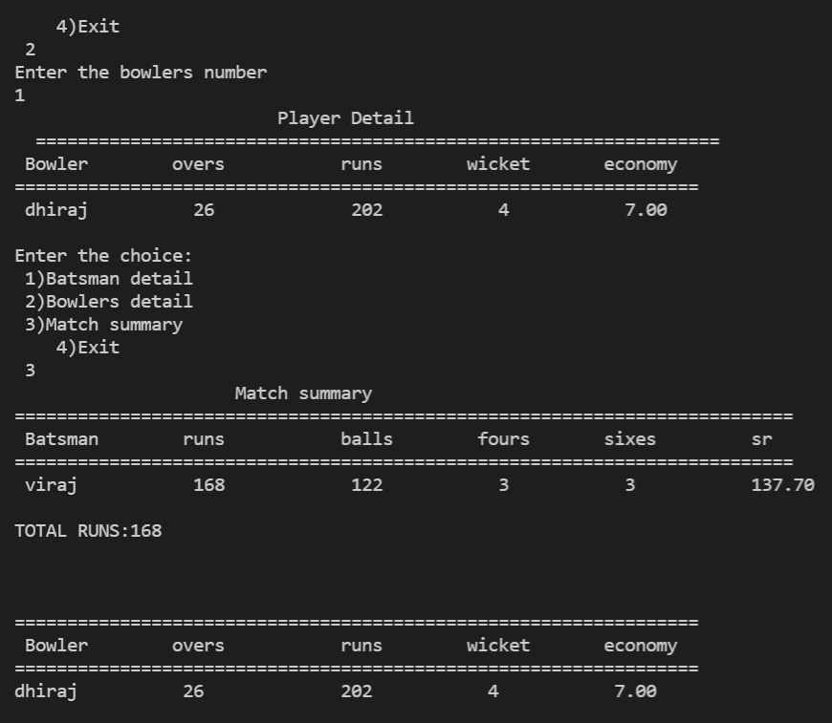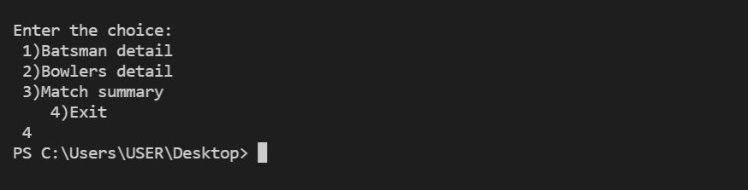

Conclusion

The cricket score card has been successfully made and managed using C language.  
Using various functions of C like struct( user define data type) and for loops and switch case, the program was able to accept data and print it according to user choice